**____________________________________________________________**

**Tips:**

* Iowa Waste Exchange allows individuals to find and donate used furniture (below in Ames Resources, Iowa Waste Exchange).
* Donating to Overflow, Goodwill, The Salvation Army, or other consignment stores is always a great option when getting rid of unwanted items.

**Examples in Smart Businesses:**

* The Loft and Duck Worth Wearing have committed themselves to near zero waste by donating unsold items to charities and offering the sale of reusable bags.
* 3M has a waste to energy program with plans to turn 100% of their waste to energy by 2021
* Mary Greeley reuses toner cartridges, linens, scrubs, and has paperless ordering and recycling to reduce landfill waste
* Hastings, Gartin, & Boettger LLP has compost collection in its break rooms
* Barilla uses terracycle to recycle hair nets, blue smocks, beard nets, and hearing protection from their production
* Wheatsfield reuses product boxes for grocery carryout as an alternative to plastic bags.

**Ames Resources**

**Food Waste Diversion Program**

Ames offers FREE composting through the [Food Waste Diversion Program](https://www.cityofames.org/government/departments-divisions-i-z/resource-recovery-system/food-waste-diversion). This resource can be used in break rooms throughout your business building to reduce organic waste.

**Paper Recycling**

The [Kiwanis Ames Golden K Club](https://amesgoldenk.org/the-paper-recycling-project/) offers a free paper recycling drop off center at 919 East Lincoln Way. Many businesses whether big or small utilize a large amount of paper, recycling this can significantly reduce your paper waste while benefiting a program.

**Iowa Waste Exchange**

The [Iowa Waste Exchange](https://www.iowadnr.gov/environmental-protection/land-quality/waste-planning-recycling/iowa-waste-exchange-iwe) assists businesses and organizations in finding outlets and opportunities to redirect business waste from the landfill or area waterways. Contact the Area Resource Specialist serving Story County, Shelene Codner, at shelly@netins.net for more details on the program!

**City of Ames Glass Recycling**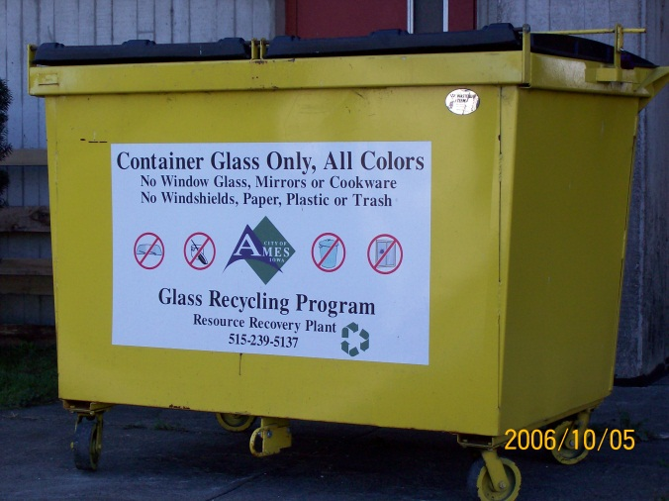

The City of Ames provides a variety of recycling opportunities for the community. Businesses with waste in the form of glass can recycle this material by dropping it off in one of the many yellow bins throughout Ames. The location of these yellow bins can be found on the [City of Ames Resource Recovery System](https://www.cityofames.org/government/departments-divisions-i-z/resource-recovery-system/glass-recycling). This can reduce your glass footprint in terms of waste and have the City of Ames recycle the glass for you with no service fee.

**City of Ames Annual Rummage Rampage**

If your business has any unneeded equipment, you can take a look into local Ames events like [Annual Ames Rummage Rampage](https://www.cityofames.org/living/rummage-rampage) to donate the equipment to help the community. An interesting fact about this program is that it was able to divert over **90,000** pounds of furniture and housewares from the landfill and more than **$40,000** was raised for local non-profit agencies in 2021.

**Other Resources**

**The Opportunities for Reusable Products**

This Reusable Packaging article gives a short insight into how products can be reused around your business. The application of multi-use and durable products can make a difference in the amount of waste your business produces throughout the year.

**Waste Reduction Tips for Small Business Owners**

This [18 Waste Reduction Tips for Small Businesses](https://www.rubicon.com/blog/waste-tips-small-businesses/) article provides opportunities for small businesses to reduce waste in daily operations. There can be many small opportunities that add up to large quantities of waste that a business can reduce.

**Implementing a Recycling Program**

Is your business looking to implement a recycling program? If yes, then you can follow this [Tips For Launching An Office Recycling Program](https://recyclenation.com/2018/02/tips-for-launching-an-office-recycling-program/) article to give you some thoughts on what you can do to make it a streamlined process.

**Terracycle Recycling**

The company Terracycle offers solutions for difficult to recycle waste. Consider hosting a drive to collect specific items through their [Free Recycling Programs](https://www.terracycle.com/en-US/brigades), or implement a [Zero Waste Box program](https://www.terracycle.com/en-US/zero_waste_boxes).

**EPA Resources on Waste**

The [EPA](https://www.epa.gov/recycle/resources-businesses-states-and-local-governments) offers many resources on pollution prevention and reduction for businesses of all sizes to use. These tools use businesses to gather data and learn more about their waste to better implement new systems or strategies.

Moreover, the [EPA Safer Choice](https://www.epa.gov/saferchoice) website can assist your business to learn more about products and services to reduce your waste footprint. The guide provides information on products that are safer for human health and the environment.

The U.S. Environmental Protection Agency has created a “[Food Recovery Hierarchy](https://www.epa.gov/sustainable-management-food/food-recovery-hierarchy)” to help businesses and organizations prevent and divert wasted food. Furthermore, the hierarchy provides different food waste management strategies at every level for you to follow along. The top levels provide the most benefits for people, our economy, and the environment.

The EPA created the [Recycled Content (ReCon) Tool](https://www.epa.gov/warm/recycled-content-recon-tool#about) to help businesses estimate the environmental impacts from purchasing and/or manufacturing materials with varying degrees of post-consumer recycled content.